
Jenkins pipelines:
- A Jenkins Pipeline is a suite of plugins that supports continuous integration and continuous delivery (CI/CD).
- It allows you to define your build, test, and deploy workflow as code inside a file called Jenkinsfile.
- Pipelines are written in Groovy DSL and can be either Declarative (structured syntax) or Scripted (flexible Groovy code).
- They provide automation, version control, and repeatability for software delivery.
Use the below code and implement our CICD stages.
- Source Code: https://github.com/betawins/hiring-app.git
  - Repository contains the application code for the hiring app.
Title:
- Create one Declarative pipeline job
Objective:
To automate the build, test, and deploy process of a Java application using Maven, ensuring code quality with SonarQube and deploying artifacts to a staging environment.
Details of the Pipeline Job
- Job Type: Jenkins Declarative Pipeline
- Source Control: GitHub repository containing application code and Jenkinsfile
- Stages:
  - Checkout → Pull latest code from GitHub.
  - Build → Compile code and package artifact using Maven.
  - Test → Run unit tests with SonarQube.
  - Code Quality → Analyze code with SonarQube.
  - Deploy → Deploy artifact to staging server Tomcat.
  - Post Actions → Notify via email/Slack if build fails or succeeds.
What is Declarative?
- Declarative Pipeline is a structured, predefined syntax (pipeline { ... }) introduced by Jenkins to simplify pipeline creation.
- It enforces a clear, human-readable format with stages and steps.
- Provides built-in error handling (post { success/failure }).
- Easier to maintain and onboard compared to Scripted Pipelines (which are pure Groovy code).
***************************************************************************
A Declarative Pipeline is a structured Jenkins pipeline defined in a Jenkinsfile with stages and steps. It’s easier to read, maintain, and enforce standards compared to scripted pipelines.”
***************************************************************************
Prerequisites for a Jenkins Declarative Pipeline
1. Jenkins Setup
- Jenkins server installed and running.
- Required plugins installed:
  - Pipeline plugin (core requirement).
  - Git plugin (for source code checkout).
  - Maven plugin (if building Java projects).
  - SonarQube plugin (for code quality checks).
  - Credentials plugin (for secure access to Git.).
2. Source Code Repository
- Application code stored in GitHub
- A Jenkinsfile created in the repo (written in Declarative syntax).
- Branch strategy defined (e.g., main for production, develop for testing).
3. Build Tools
- Build system installed on Jenkins agent:
  - Mavenfor Java.
- Dependencies defined in pom.xml.

4. Credentials & Access
- Jenkins configured with:
  - Git credentials (only a private repo)
  - Artifact repo credentials (Nexus/Artifactory).
  - Deployment credentials (Tomcat Credentials)
5. Environment Setup
- Network access to Git repo, artifact repo, and deployment targets.
- Proper workspace cleanup policy to avoid conflicts.
6. Notification Tools (Optional but Recommended)
- Notification channels (Slack, Email) integrated with Jenkins.
Step By Step Implementation:
Launch all servers
Sign into Jenkins
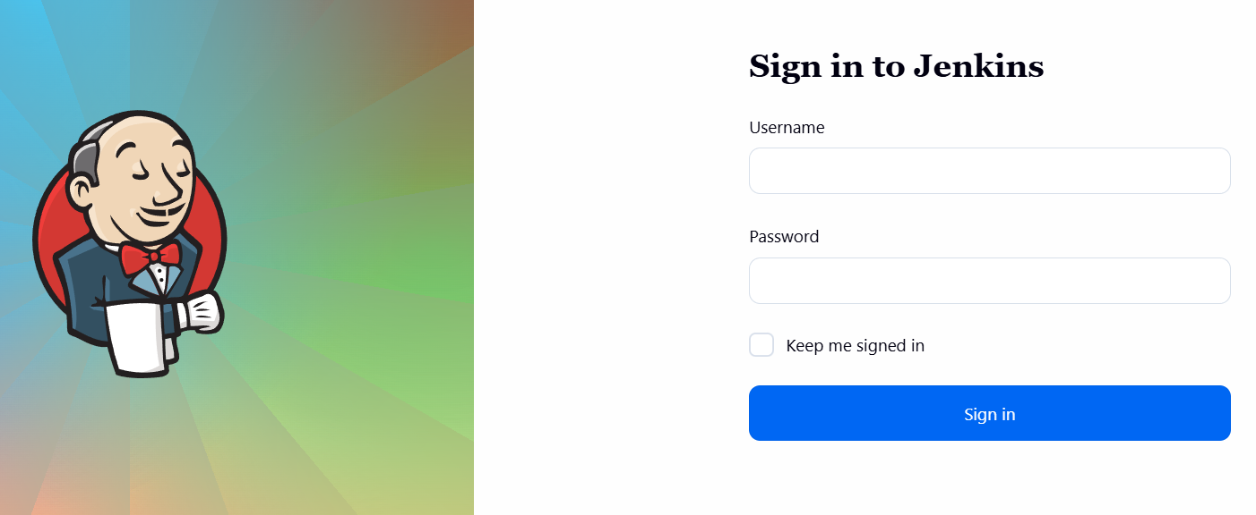

After that you will redirect to the dashboard
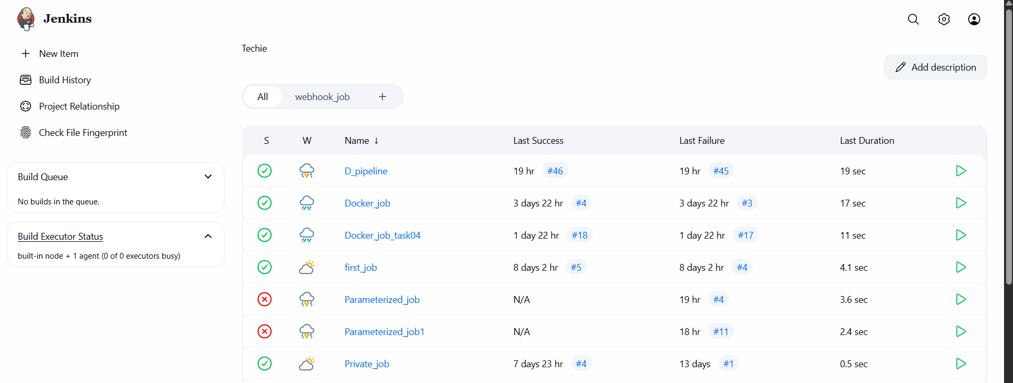
After that start sonarqube server using command
Login to ec2 and switch to root and start sonarqube..
docker run -itd -p 9000:9000 sonarqube
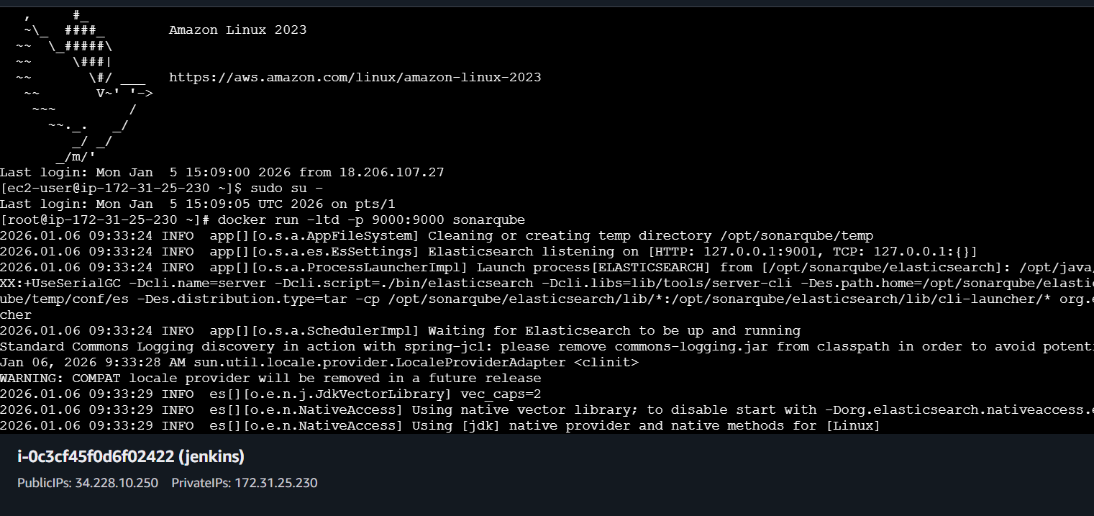
You will be signed into SONARQUBE dashboard login with
admin and admin username and password
everytime you restart the sonarqube a new credentials are needed

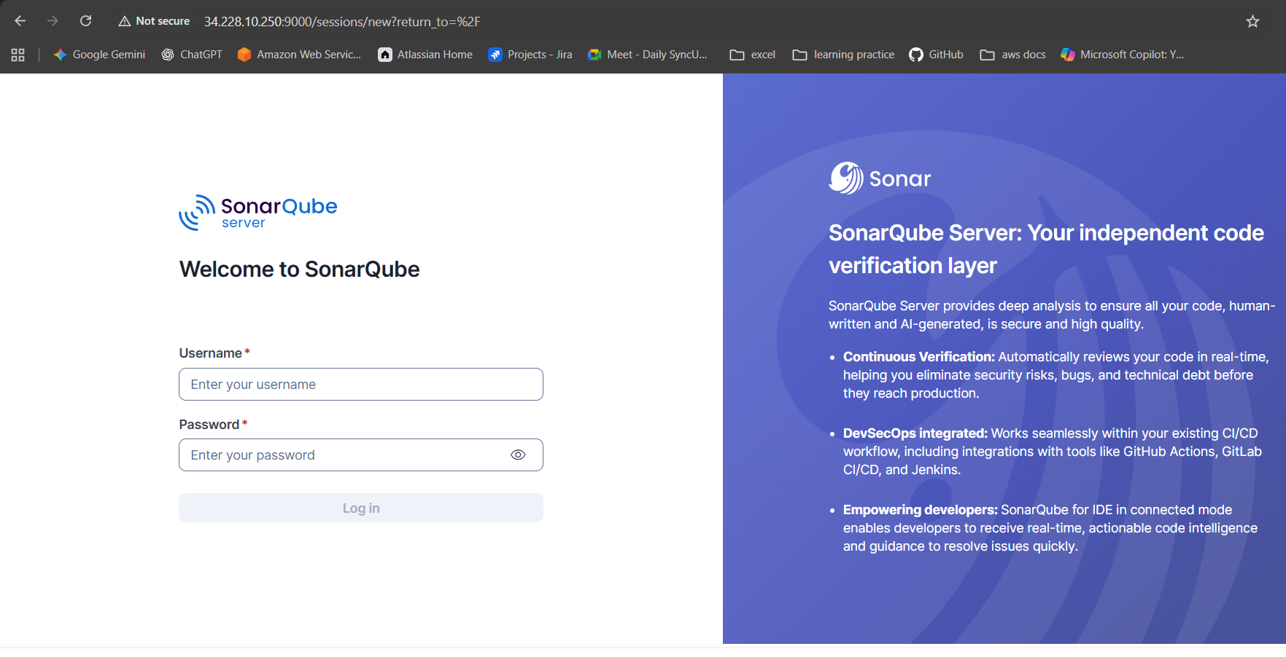
After logged in goto click on profile and click on settings
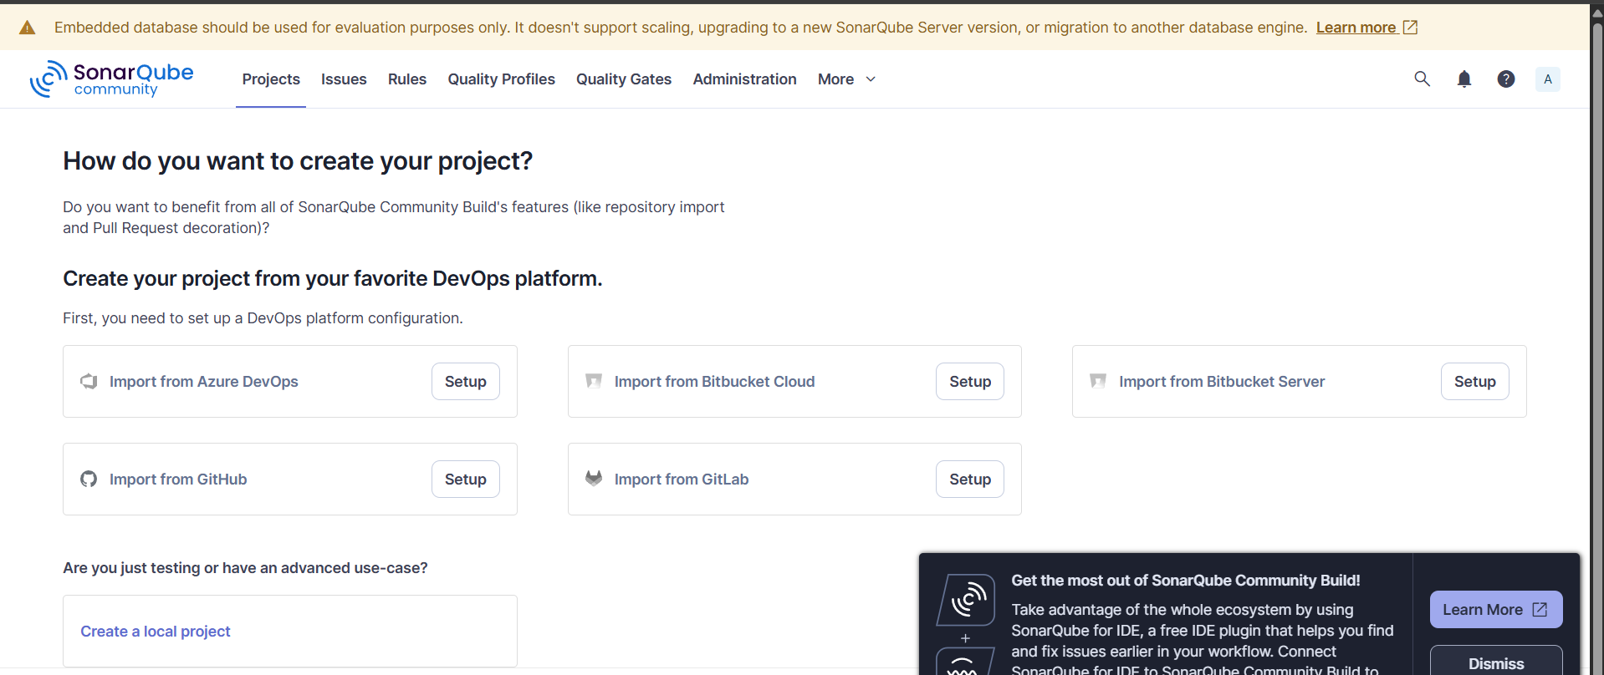
In the security generate a token and continue with copying
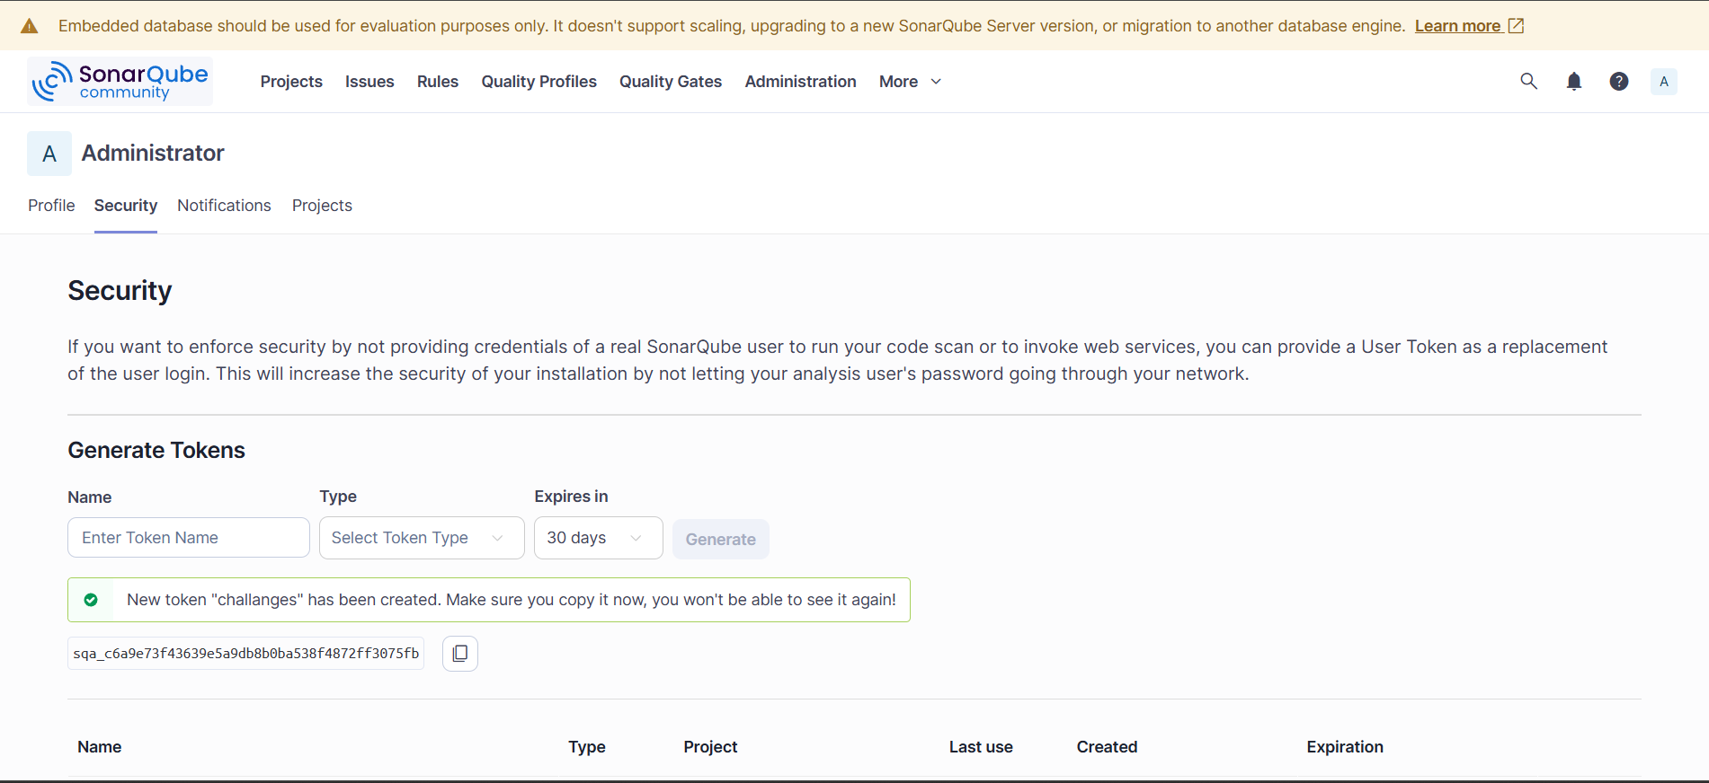
Again navigate back to Jenkins and click on settings and goto manage Jenkins and
Click on system settings and change the details of sonarqube with new ip and credentials
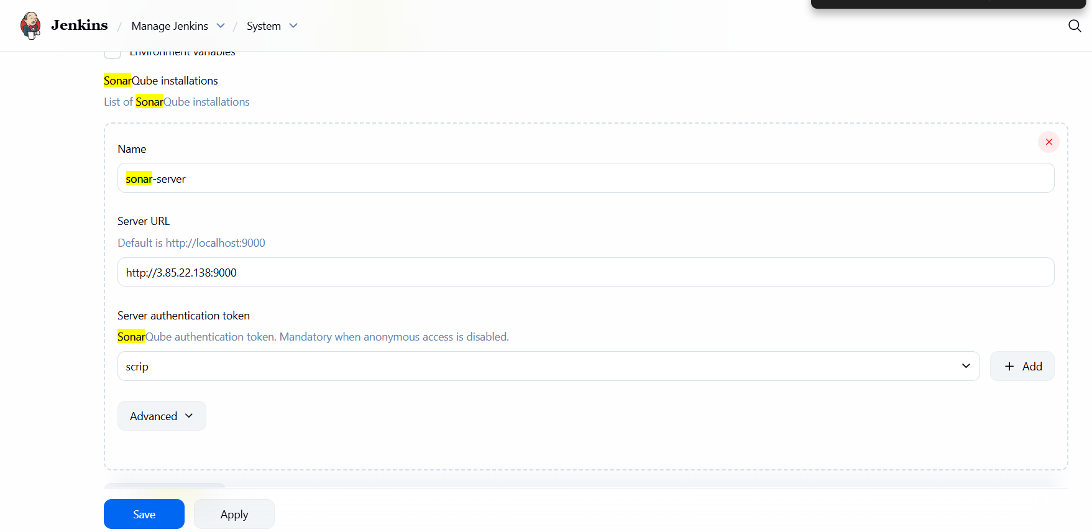

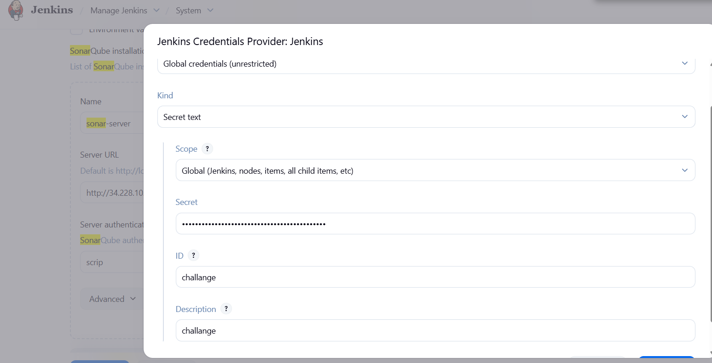

After updating the details
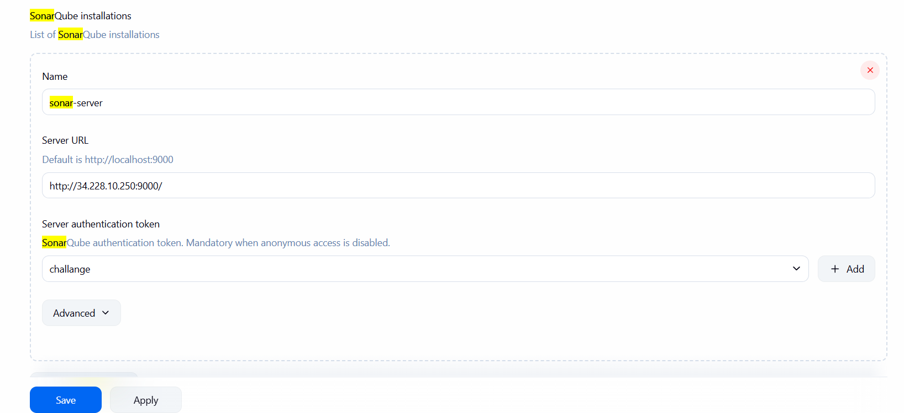
Now we need to launch nexus server so that connect to ec2 and start using ./nexus start command
In cd /opt/nexus/bin directory..
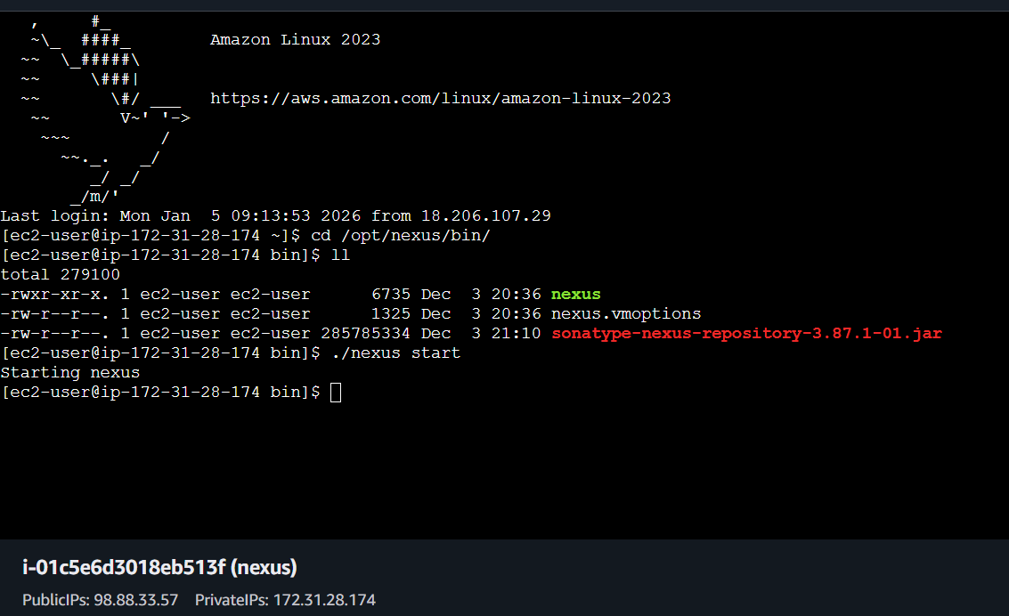

IF the nexus is not started then change the ownership of file and then start again
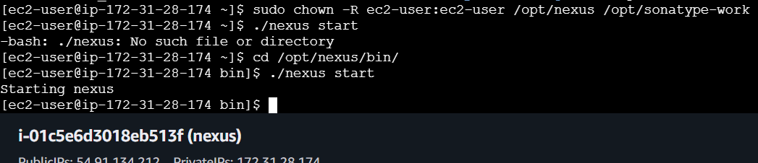
In the webite logged in with your credentials and continue
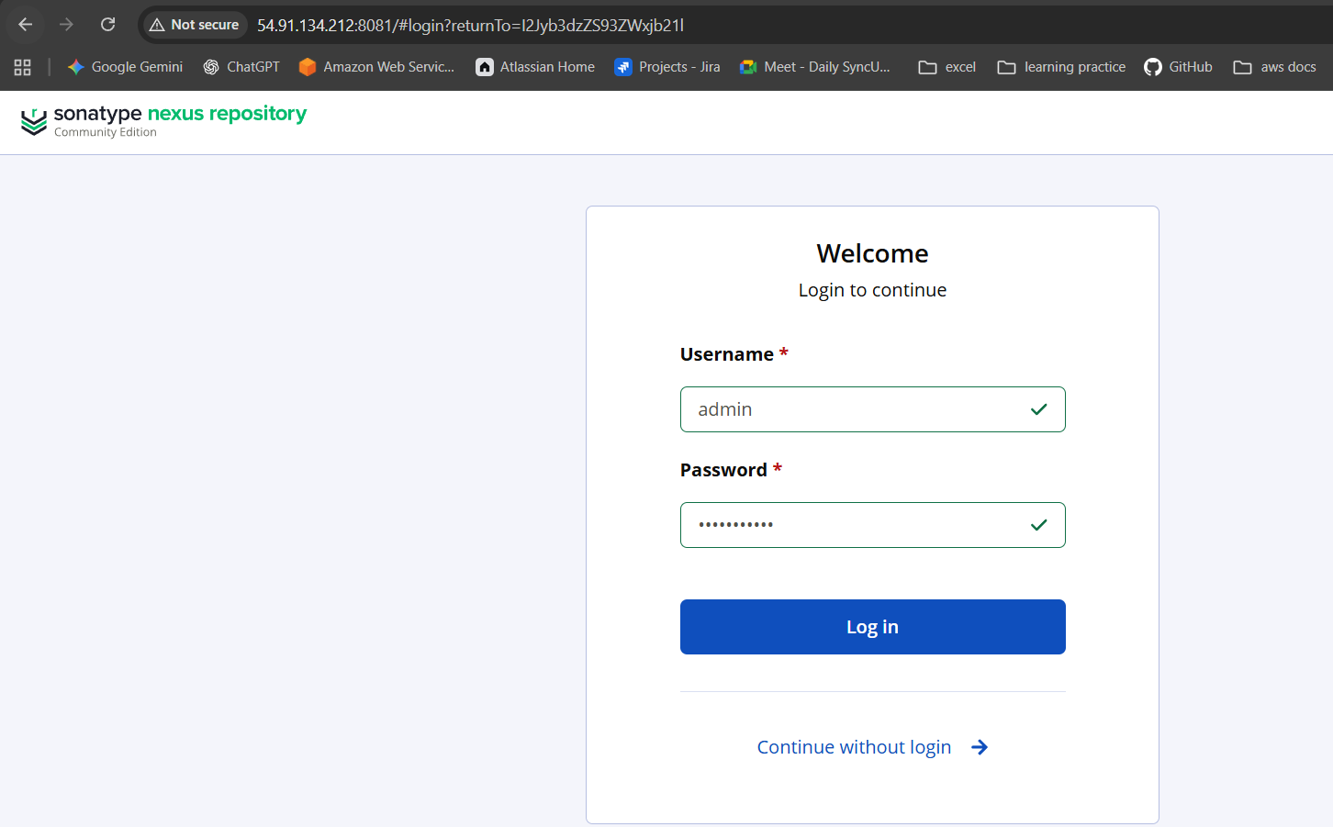
Also create a dedicated repo for storing artifacts and copy the name
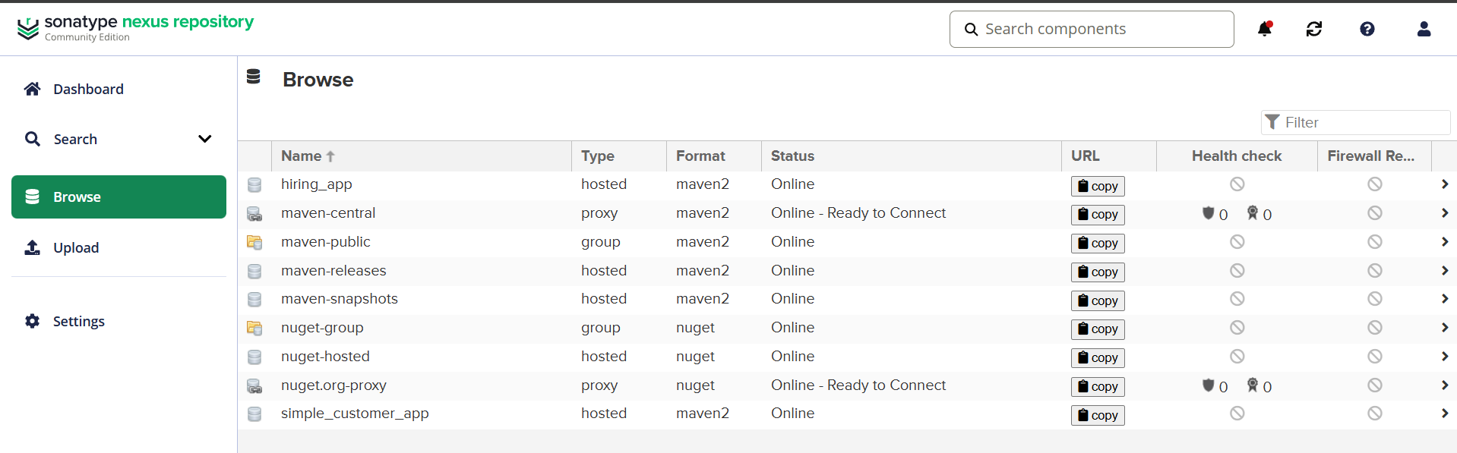

At last launch and ec2 and launch tomcat
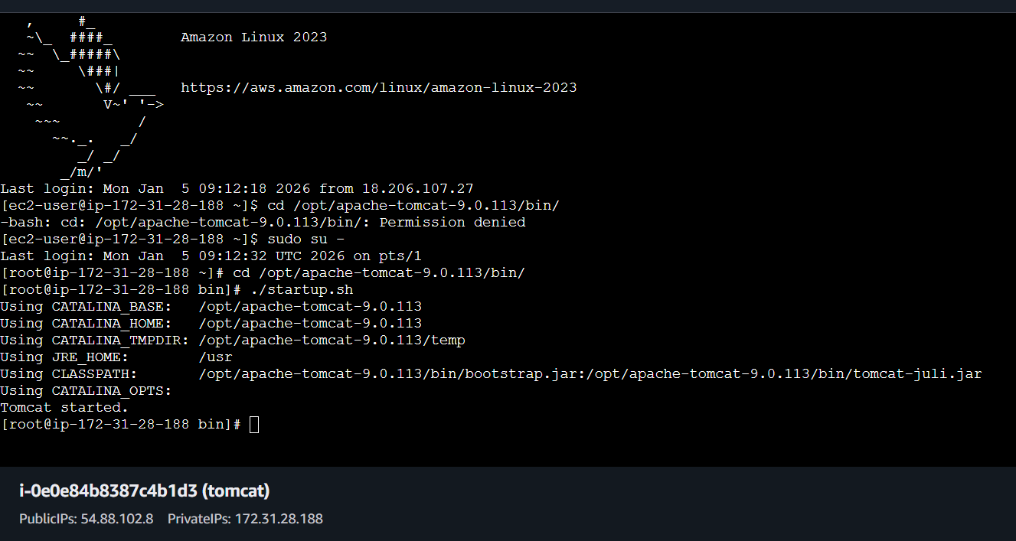
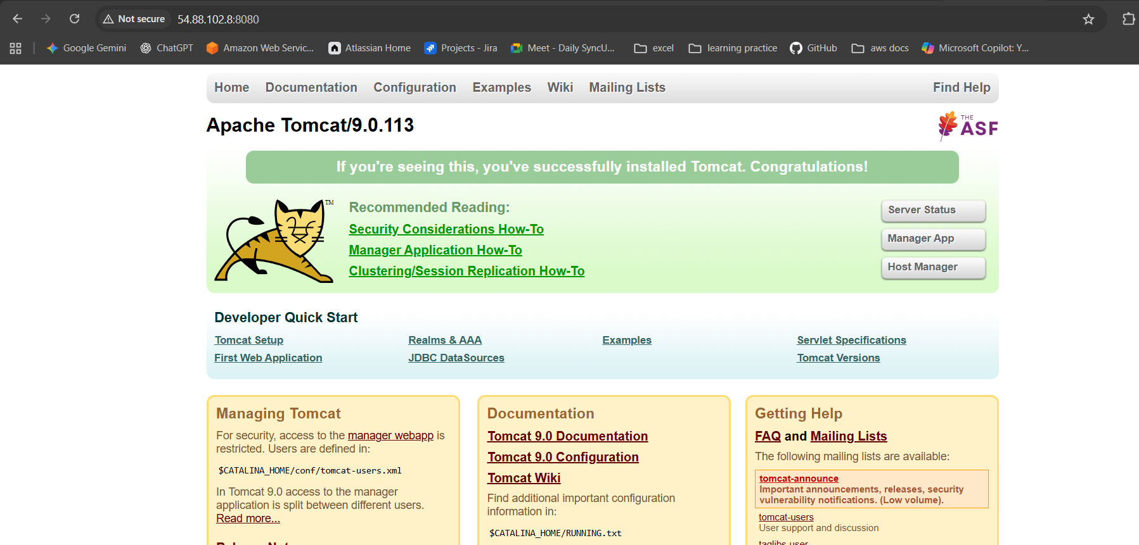

Now we will do the main thing of descriptive pipeline
Click on new item and select the type called pipeline and continue
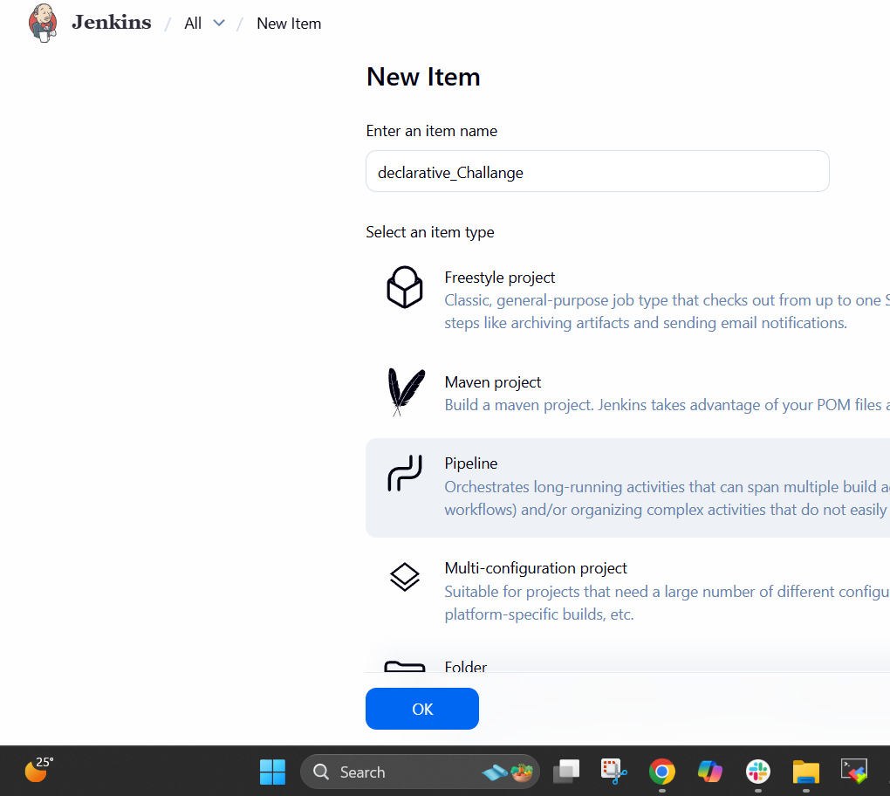
Give the description and its optional
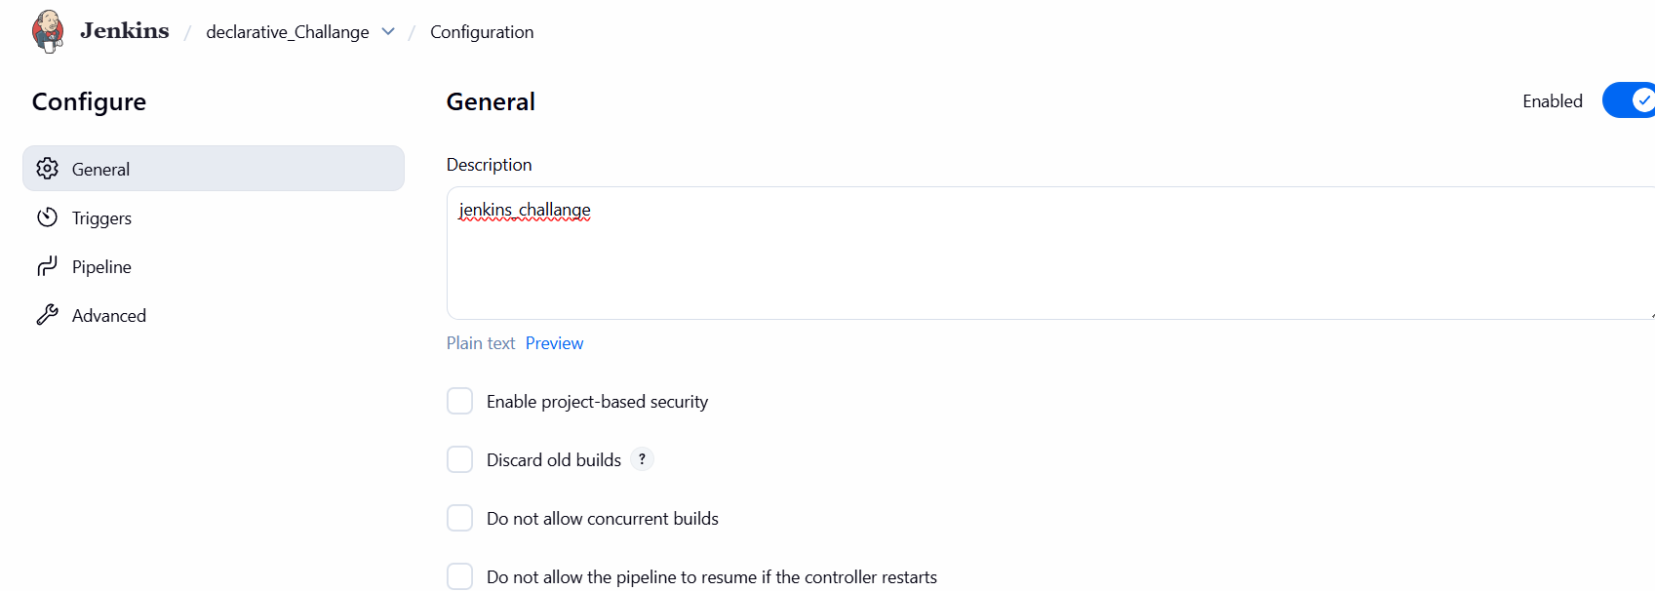

After that enter the pipeline in groovy language and continue by saving it
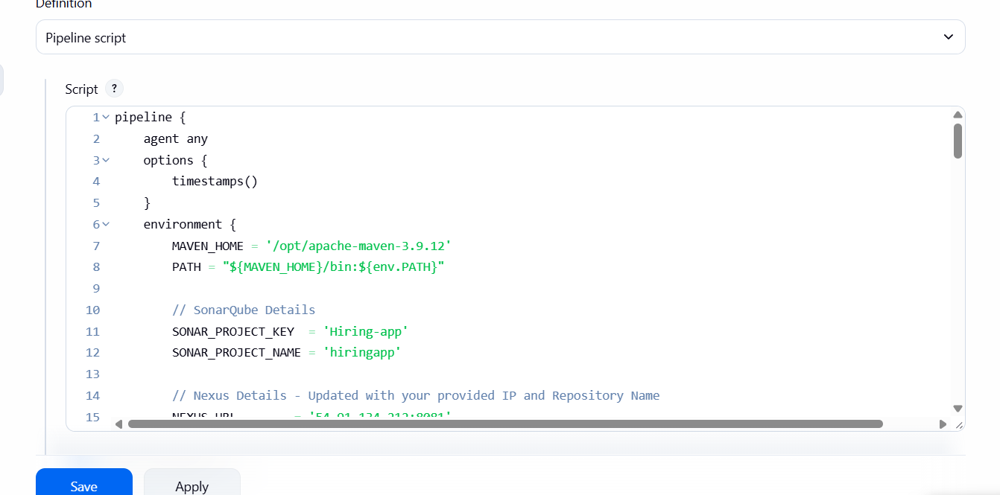
After some builds the job was passed
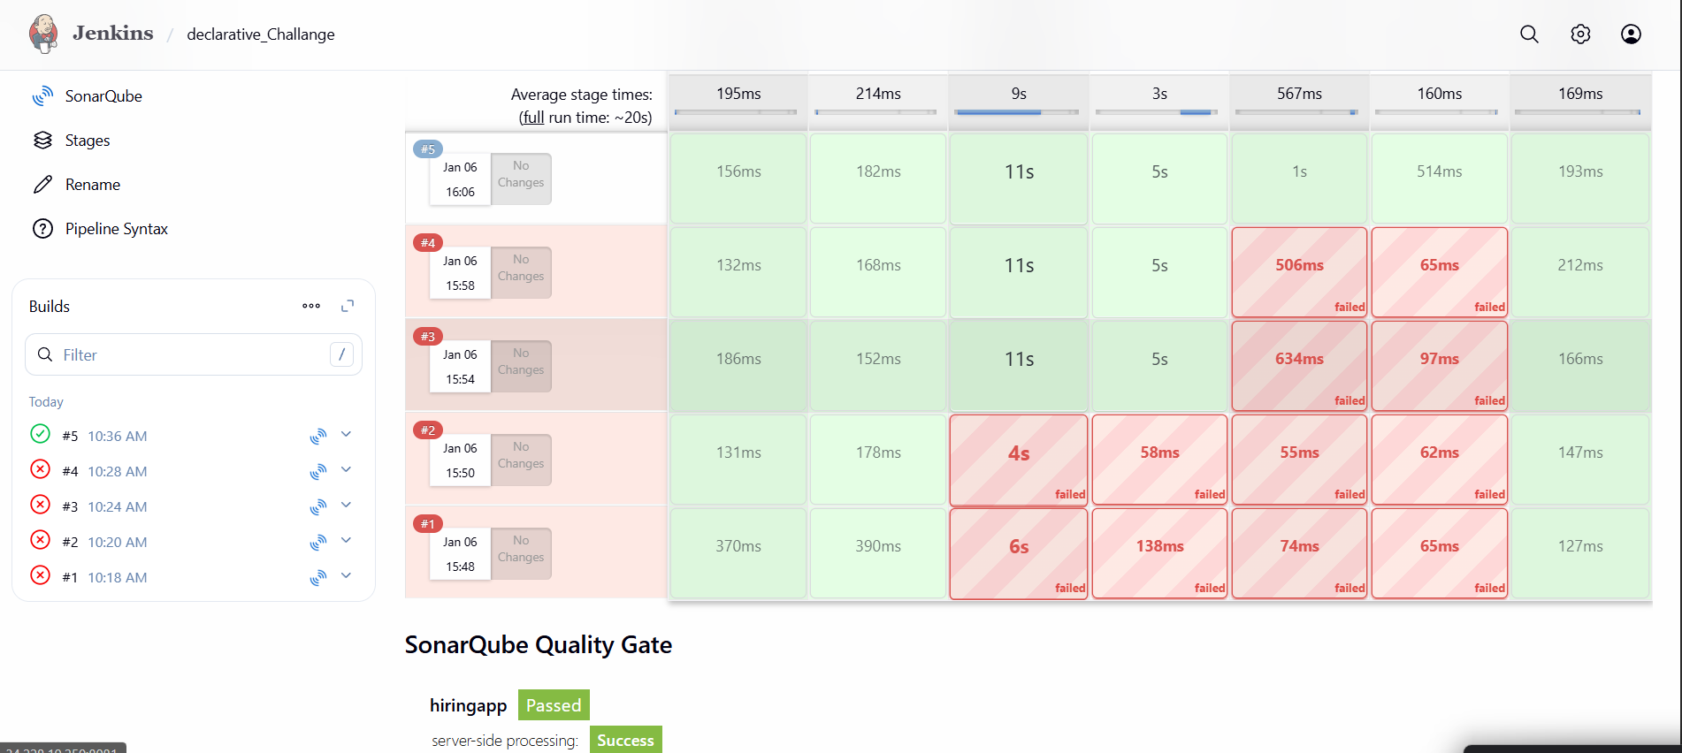
Deployment validation
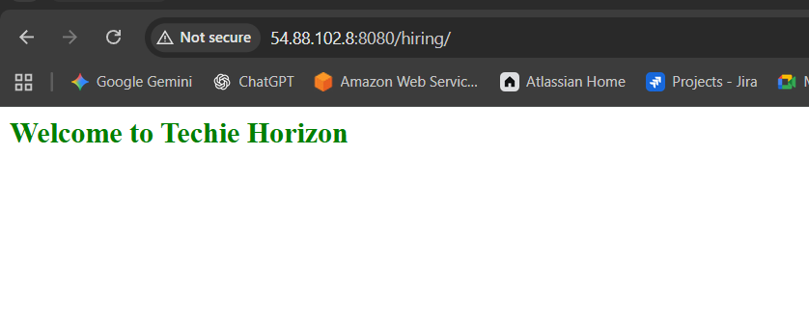
My pipeline::
pipeline {
agent any
options {
timestamps()
}
environment {
MAVEN_HOME = '/opt/apache-maven-3.9.12'
PATH = "${MAVEN_HOME}/bin:${env.PATH}"

// SonarQube Details
SONAR_PROJECT_KEY = 'Hiring-app'
SONAR_PROJECT_NAME = 'hiringapp'

// Nexus Details - Updated with your provided IP and Repository Name
NEXUS_URL = '54.91.134.212:8081'
NEXUS_REPOSITORY = 'hiring_app'
NEXUS_VERSION = 'nexus3'
NEXUS_PROTOCOL = 'http'

// Tomcat Details - Updated with your provided IP
TOMCAT_URL = 'http://54.88.102.8:8080'
}
stages {
stage('Notify Started') {
steps {
slackSend(
color: '#439FE0',
message: "Attaluri Sai Teja | ${env.JOB_NAME} - #${env.BUILD_NUMBER} Started (<${env.BUILD_URL}|Open>)",
tokenCredentialId: 'slack_notification'
)
}
}
stage('Git Clone') {
steps {
git branch: 'main',
url: 'https://github.com/betawins/hiring-app.git'
}
}
stage('SonarQube Analysis') {
steps {
// Using 'sonar-server' to match your previous Jenkins configuration
withSonarQubeEnv('sonar-server') {
sh '''
mvn clean verify \
org.sonarsource.scanner.maven:sonar-maven-plugin:sonar \
-Dsonar.projectKey=${SONAR_PROJECT_KEY} \
-Dsonar.projectName=${SONAR_PROJECT_NAME}
'''
}
}
}
stage('Maven Build') {
steps {
sh 'mvn clean package -DskipTests'
}
}
stage('Nexus Upload') {
steps {
script {
def WAR_FILE = sh(
script: "ls target/*.war",
returnStdout: true
).trim()

// Uses the Nexus Artifact Uploader Plugin
nexusArtifactUploader(
nexusVersion: NEXUS_VERSION,
protocol: NEXUS_PROTOCOL,
nexusUrl: NEXUS_URL,
repository: NEXUS_REPOSITORY,
credentialsId: 'nexus_server', // Updated to match your credential ID
groupId: 'in.javahome',
version: "${env.BUILD_NUMBER}-SNAPSHOT",
artifacts: [[
artifactId: 'hiring',
classifier: '',
type: 'war',
file: WAR_FILE
]]
)
}
}
}
stage('Deploy to Tomcat') {
steps {
deploy adapters: [
tomcat9(
credentialsId: 'tomcat', // Updated to match your credential ID
url: "${TOMCAT_URL}"
)
],
contextPath: 'sabear',
war: 'target/*.war'
}
}
}
post {
success {
slackSend(
color: 'good',
message: "Attaluri Sai Teja | ${env.JOB_NAME} - #${env.BUILD_NUMBER} Success (<${env.BUILD_URL}|Open>)",
tokenCredentialId: 'slack_notification'
)
}
failure {
slackSend(
color: 'danger',
message: "Attaluri Sai Teja | ${env.JOB_NAME} - #${env.BUILD_NUMBER} Failed (<${env.BUILD_URL}|Open>)",
tokenCredentialId: 'slack_notification'
)
}
}
}
ERRORS FACED AND FIXED
Fix the Jenkins Pipeline Error
- The Issue: You are getting a NullPointerException because the credential ID challange is stored as "Secret text".
- The Fix: Delete that credential and recreate it as a "Username with password" type so the plugin can read both the username and password.
Nexus Repository Sync
- The Policy: Your repository is set to MIXED, which is perfect for your build since it allows the -SNAPSHOT versioning defined in your Jenkinsfile.
- The Deployment: Ensure your Nexus repository is set to "Allow redeploy" so you can run the pipeline multiple times without "400 Bad Request" errors.

TITLE::
- Create one Scripted pipeline job
What is a Scripted Pipeline?
A Scripted Pipeline is the traditional way of writing Jenkins pipelines using Groovy code. Unlike Declarative Pipelines (which use a strict, pre-defined structure), Scripted Pipelines offer maximum flexibility. They run within a node block and allow you to use complex logic, loops, and try-catch blocks for advanced error handling.

Prerequisites
- Infrastructure: An EC2 instance (minimum m7i.flex or equivalent with 8GB RAM).
- Java: Java 8 or 11 must be installed and active (Nexus will not run on Java 21).
- Jenkins Plugins: Git, Maven Integration, Pipeline, SonarQube Scanner, Nexus Artifact Uploader, and Slack Notification.
- Credentials: * nexus_server: Username with password type (NOT Secret text).
  - tomcat: Username with password for the Tomcat manager.
  - slack_notification: Secret text for the Slack API token.
Step by Step Implementation:
Navigate to Jenkins and click on new item and create pipeline type job
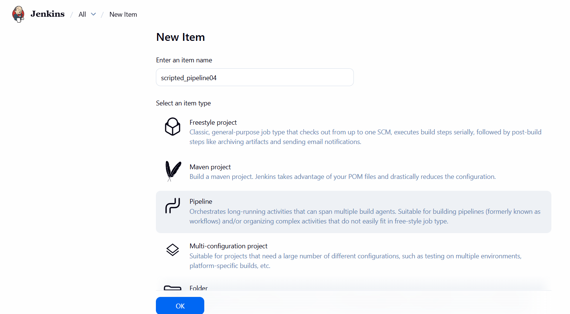

Paste the script and save it
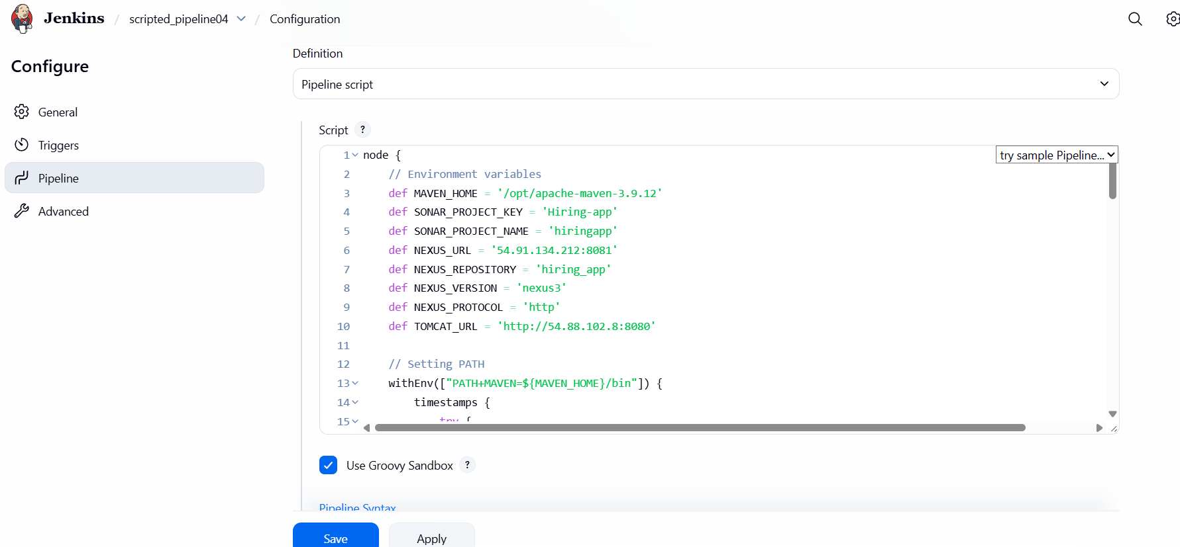
Click on build to check the pipeline
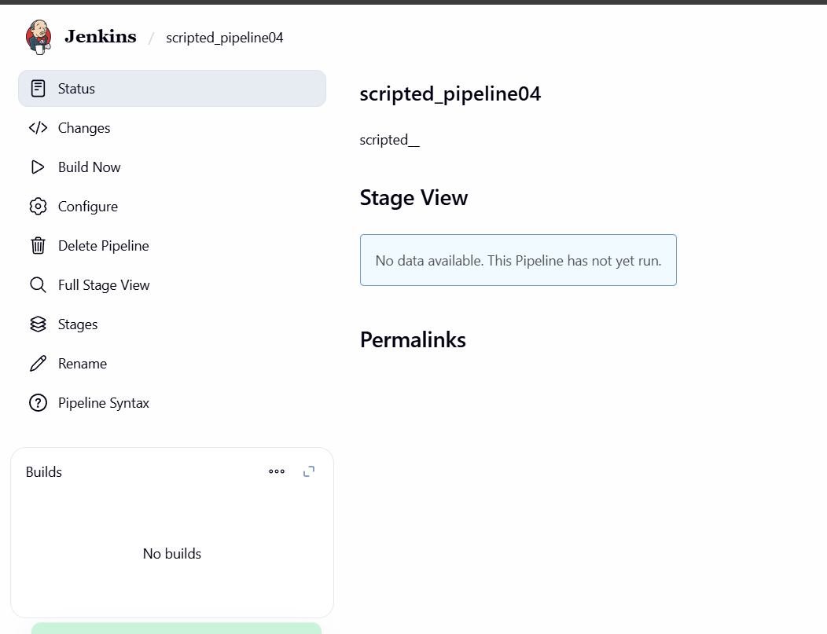

That’s done pipeline is executed successfully
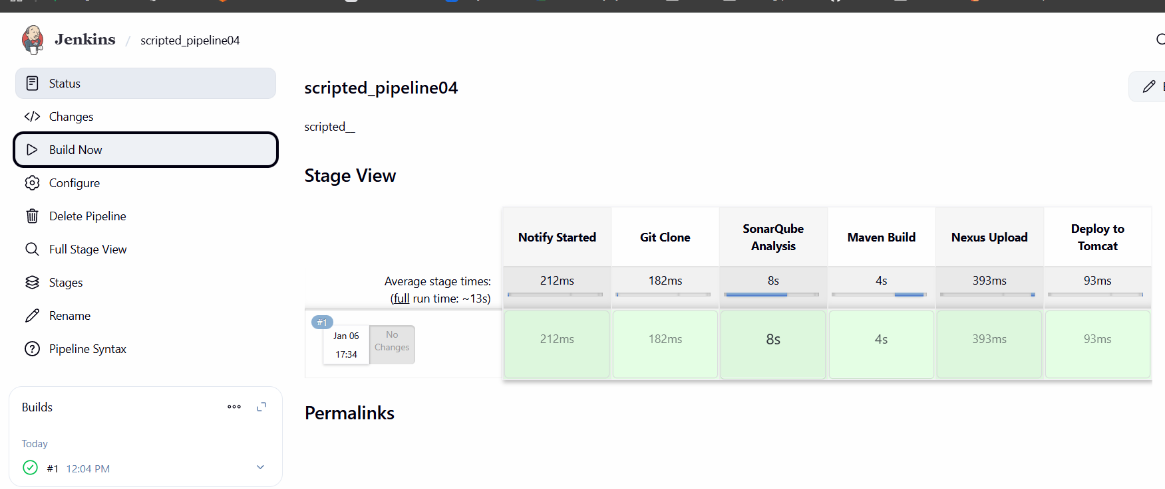
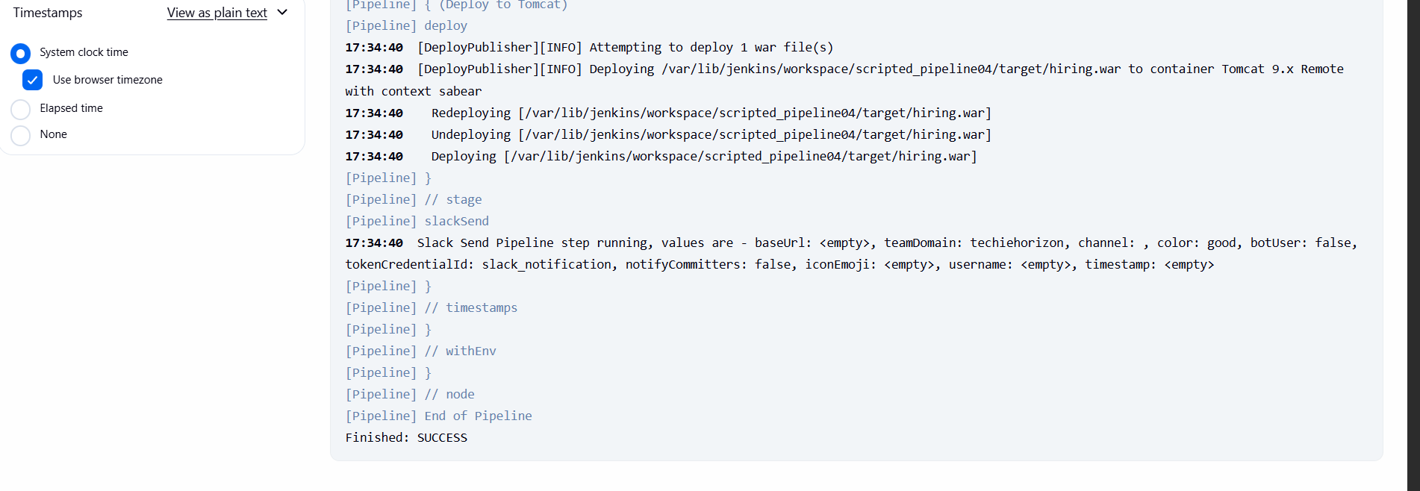
Also validate in slack
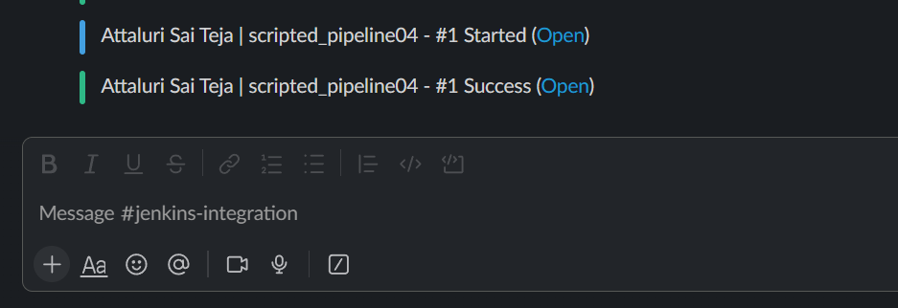

The Pipeline Which I Used
node {
// Environment variables
def MAVEN_HOME = '/opt/apache-maven-3.9.12'
def SONAR_PROJECT_KEY = 'Hiring-app'
def SONAR_PROJECT_NAME = 'hiringapp'
def NEXUS_URL = '54.91.134.212:8081'
def NEXUS_REPOSITORY = 'hiring_app'
def NEXUS_VERSION = 'nexus3'
def NEXUS_PROTOCOL = 'http'
def TOMCAT_URL = 'http://54.88.102.8:8080'

// Setting PATH
withEnv(["PATH+MAVEN=${MAVEN_HOME}/bin"]) {
timestamps {
try {
stage('Notify Started') {
slackSend(
color: '#439FE0',
message: "Attaluri Sai Teja | ${env.JOB_NAME} - #${env.BUILD_NUMBER} Started (<${env.BUILD_URL}|Open>)",
tokenCredentialId: 'slack_notification'
)
}

stage('Git Clone') {
git branch: 'main', url: 'https://github.com/betawins/hiring-app.git'
}

stage('SonarQube Analysis') {
withSonarQubeEnv('sonar-server') {
sh """
mvn clean verify \
org.sonarsource.scanner.maven:sonar-maven-plugin:sonar \
-Dsonar.projectKey=${SONAR_PROJECT_KEY} \
-Dsonar.projectName=${SONAR_PROJECT_NAME}
"""
}
}

stage('Maven Build') {
sh 'mvn clean package -DskipTests'
}

stage('Nexus Upload') {
def WAR_FILE = sh(script: "ls target/*.war", returnStdout: true).trim()

nexusArtifactUploader(
nexusVersion: NEXUS_VERSION,
protocol: NEXUS_PROTOCOL,
nexusUrl: NEXUS_URL,
repository: NEXUS_REPOSITORY,
credentialsId: 'nexus_server',
groupId: 'in.javahome',
version: "${env.BUILD_NUMBER}-SNAPSHOT",
artifacts: [[
artifactId: 'hiring',
classifier: '',
type: 'war',
file: WAR_FILE
]]
)
}

stage('Deploy to Tomcat') {
deploy adapters: [
tomcat9(
credentialsId: 'tomcat',
url: "${TOMCAT_URL}"
)
],
contextPath: 'sabear',
war: 'target/*.war'
}

// Success Post-Action
slackSend(
color: 'good',
message: "Attaluri Sai Teja | ${env.JOB_NAME} - #${env.BUILD_NUMBER} Success (<${env.BUILD_URL}|Open>)",
tokenCredentialId: 'slack_notification'
)

} catch (Exception e) {
// Failure Post-Action
slackSend(
color: 'danger',
message: "Attaluri Sai Teja | ${env.JOB_NAME} - #${env.BUILD_NUMBER} Failed (<${env.BUILD_URL}|Open>)",
tokenCredentialId: 'slack_notification'
)
throw e // Ensure the build still shows as failed in Jenkins
}
}
}
}

Title:
- Create one multi stage pipeline job

What is a Multi-Stage Scripted Pipeline?
A Scripted Pipeline is the original way to write Jenkins pipelines using Groovy. It provides maximum flexibility, allowing you to use complex logic and loops. By dividing it into Stages, you create a "Multi-Stage" workflow where each part of the process (Clone, Build, Test, Deploy) is clearly separated for better monitoring and error tracking.

Objective:
To automate the end-to-end delivery of the "Hiring App" by integrating code scanning, artifact archiving in a Nexus MIXED repository, and automated deployment to a Tomcat 9 server.

Prerequisites
Before running this pipeline, ensure your environment is configured correctly:
- Hardware: An EC2 instance (e.g., m7i.flex) with at least 8GB of RAM for Nexus.
- Java Environment: Ensure Java 11 is the active version; Nexus 3 will shut down if Java 21 is detected.
- Jenkins Credentials:
  - nexus_server: Must be Username with password type (not "Secret text").
  - tomcat: Username/Password for the Tomcat manager.
  - slack_notification: Secret text for API access.

Difference between declarative and multistage pipeline
Feature | Declarative (Descriptive) | Scripted (Multi-Stage Capable)
Learning Curve | Low; very intuitive for beginners. | High; requires Groovy programming knowledge.
Flexibility | Limited by a pre-defined structure. | Unlimited; can handle any complex logic.
Syntax Validation | Validated before execution begins. | Fails only when it hits the error during runtime.
Error Handling | Simple, intuitive mechanisms. | Granular and powerful using try-catch.

Step by Step Implementation
Click on new item and create a job naming multistage and continue
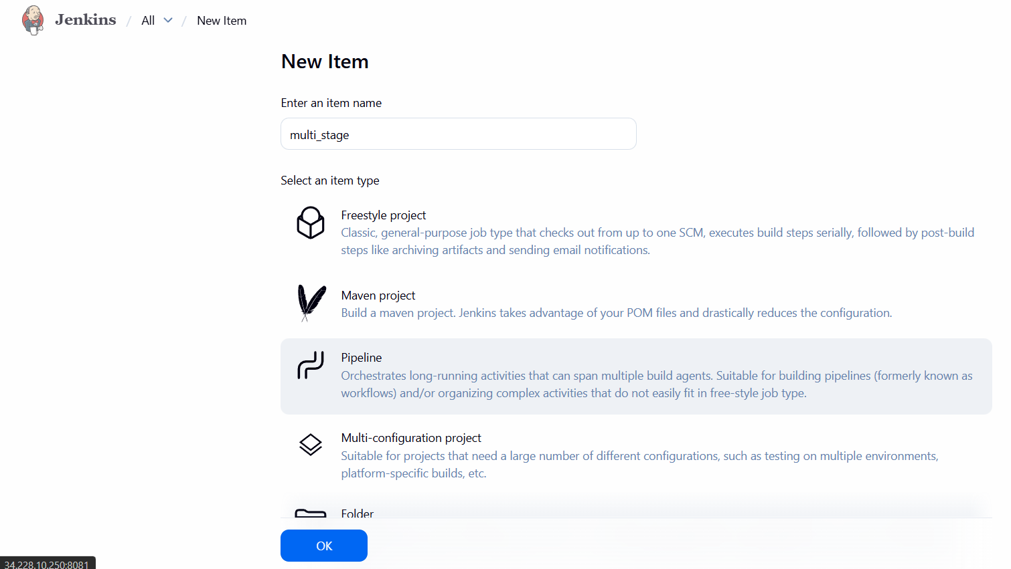
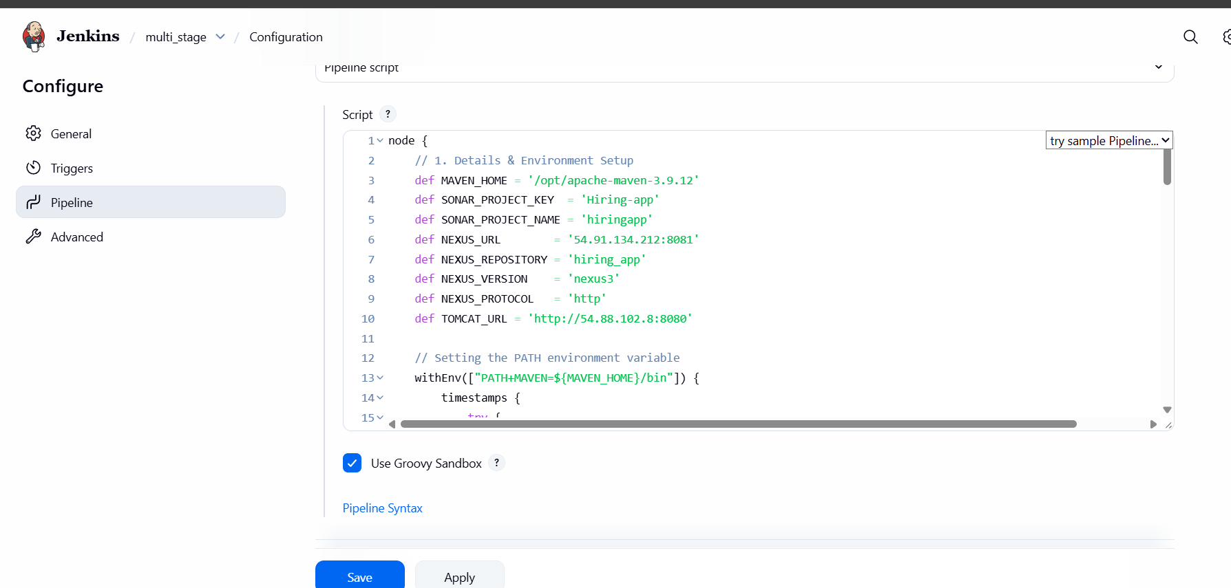
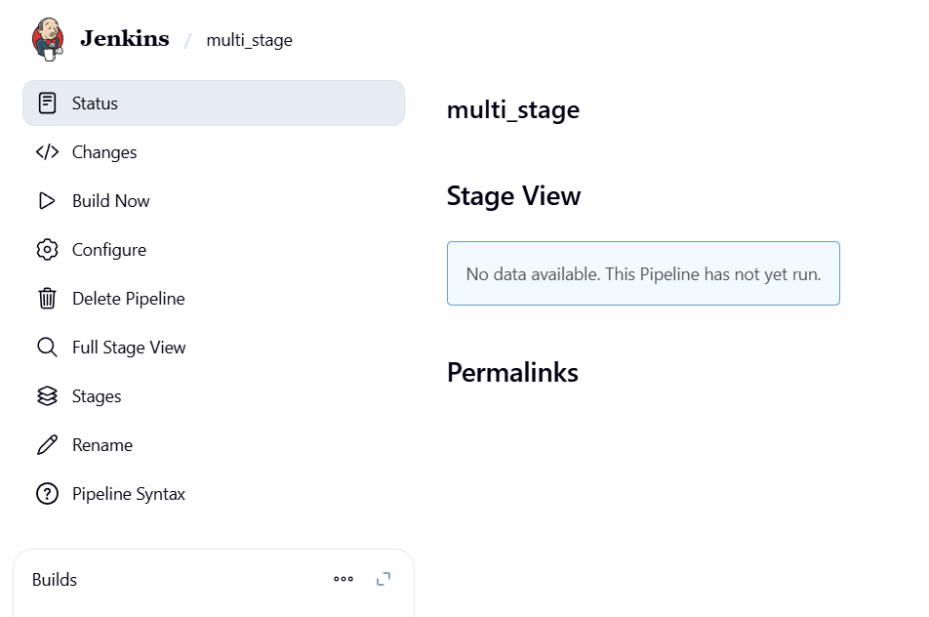
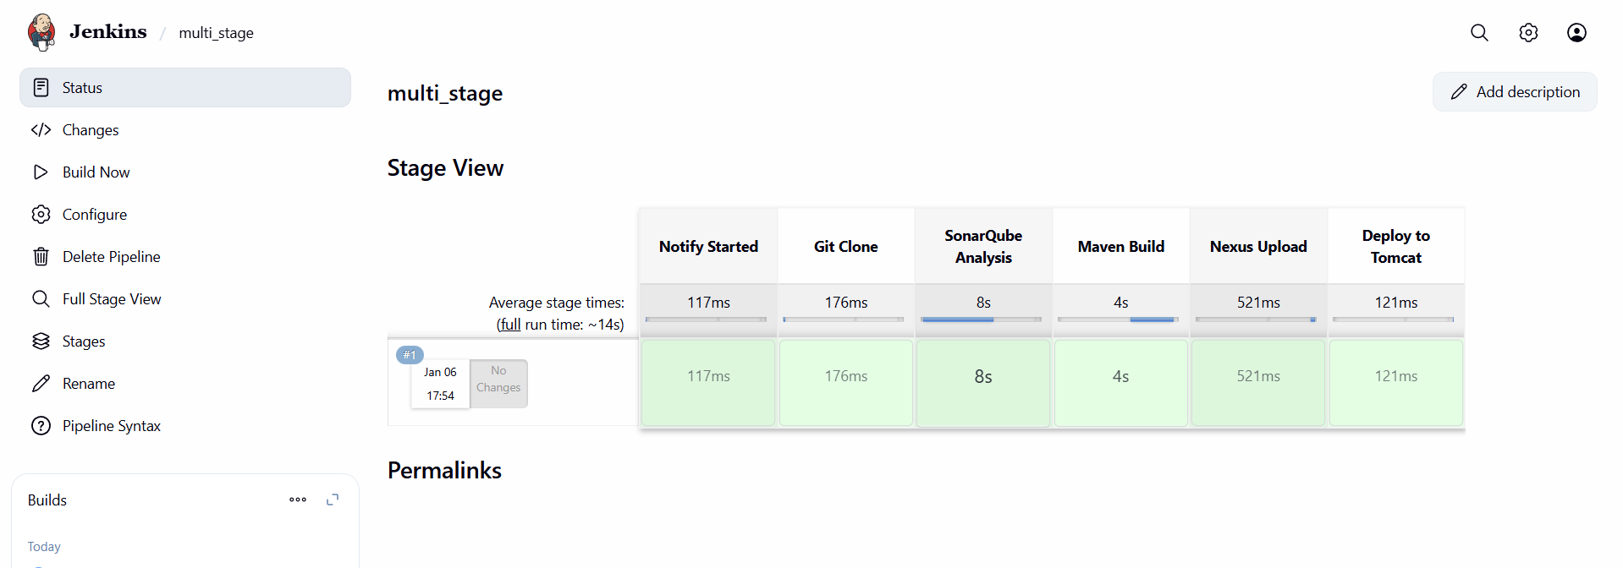
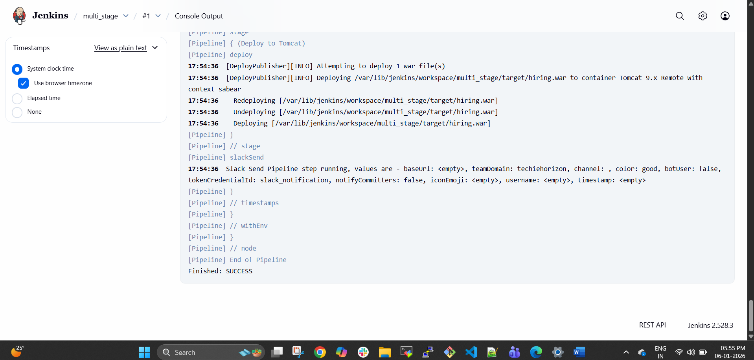
Successfully executed
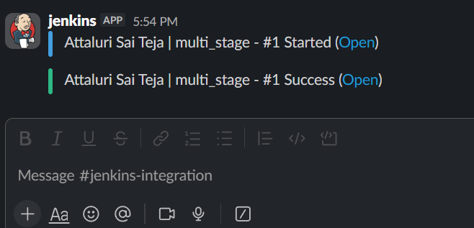

The pipeline which I used:
node {
// 1. Details & Environment Setup
def MAVEN_HOME = '/opt/apache-maven-3.9.12'
def SONAR_PROJECT_KEY = 'Hiring-app'
def SONAR_PROJECT_NAME = 'hiringapp'
def NEXUS_URL = '54.91.134.212:8081'
def NEXUS_REPOSITORY = 'hiring_app'
def NEXUS_VERSION = 'nexus3'
def NEXUS_PROTOCOL = 'http'
def TOMCAT_URL = 'http://54.88.102.8:8080'

// Setting the PATH environment variable
withEnv(["PATH+MAVEN=${MAVEN_HOME}/bin"]) {
timestamps {
try {
stage('Notify Started') {
slackSend(
color: '#439FE0',
message: "Attaluri Sai Teja | ${env.JOB_NAME} - #${env.BUILD_NUMBER} Started (<${env.BUILD_URL}|Open>)",
tokenCredentialId: 'slack_notification'
)
}

stage('Git Clone') {
git branch: 'main',
url: 'https://github.com/betawins/hiring-app.git'
}

stage('SonarQube Analysis') {
withSonarQubeEnv('sonar-server') {
sh """
mvn clean verify \
org.sonarsource.scanner.maven:sonar-maven-plugin:sonar \
-Dsonar.projectKey=${SONAR_PROJECT_KEY} \
-Dsonar.projectName=${SONAR_PROJECT_NAME}
"""
}
}

stage('Maven Build') {
sh 'mvn clean package -DskipTests'
}

stage('Nexus Upload') {
def WAR_FILE = sh(
script: "ls target/*.war",
returnStdout: true
).trim()

nexusArtifactUploader(
nexusVersion: NEXUS_VERSION,
protocol: NEXUS_PROTOCOL,
nexusUrl: NEXUS_URL,
repository: NEXUS_REPOSITORY,
credentialsId: 'nexus_server',
groupId: 'in.javahome',
version: "${env.BUILD_NUMBER}-SNAPSHOT",
artifacts: [[
artifactId: 'hiring',
classifier: '',
type: 'war',
file: WAR_FILE
]]
)
}

stage('Deploy to Tomcat') {
deploy adapters: [
tomcat9(
credentialsId: 'tomcat',
url: "${TOMCAT_URL}"
)
],
contextPath: 'sabear',
war: 'target/*.war'
}

// Success Notification
slackSend(
color: 'good',
message: "Attaluri Sai Teja | ${env.JOB_NAME} - #${env.BUILD_NUMBER} Success (<${env.BUILD_URL}|Open>)",
tokenCredentialId: 'slack_notification'
)

} catch (Exception e) {
// Failure Notification
slackSend(
color: 'danger',
message: "Attaluri Sai Teja | ${env.JOB_NAME} - #${env.BUILD_NUMBER} Failed (<${env.BUILD_URL}|Open>)",
tokenCredentialId: 'slack_notification'
)
throw e // Rethrow to ensure Jenkins marks build as failed
}
}
}
}
Conclusion
If you want an easy-to-manage process that your whole team can understand, use a Declarative Pipeline with multiple stages. If your process is highly complex and requires custom programming logic that standard stages can't handle, use a Scripted Pipeline.

Title:
- Create one parallel stage pipeline job
What is a Parallel Pipeline?
In a parallel pipeline, stages that do not depend on each other are executed at the same time on the same node or different agents. For your project, since SonarQube just reads the code and Maven packages it, they can run together to save time.
Objective:
To decrease delivery lead time by executing the Quality Analysis and the Packaging stages in parallel, while maintaining the end-to-end flow from Git to Tomcat.
Prerequisites
- Hardware: An EC2 instance (m7i.flex) with 8GB RAM to support concurrent Java processes.
- Java: Version 11 must be active for Nexus compatibility.
- Credentials: nexus_server must be Username with password type.
Step by Step Implementation:
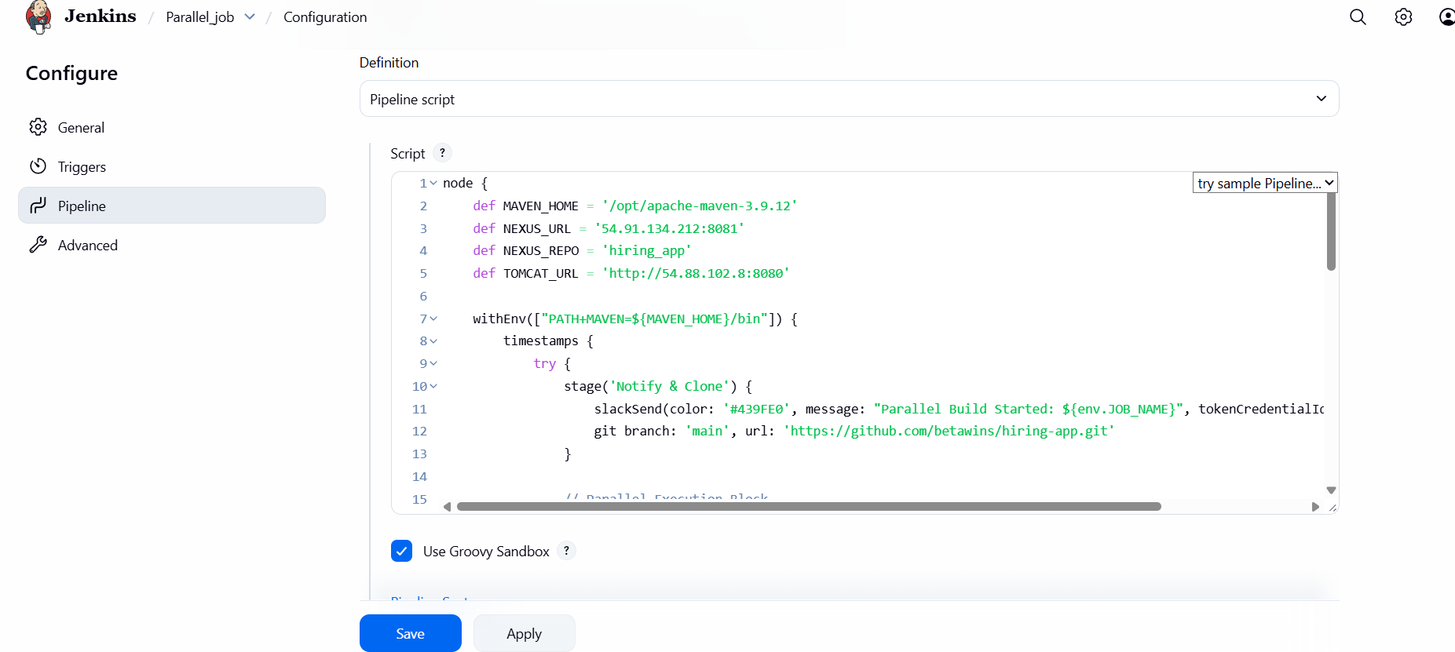
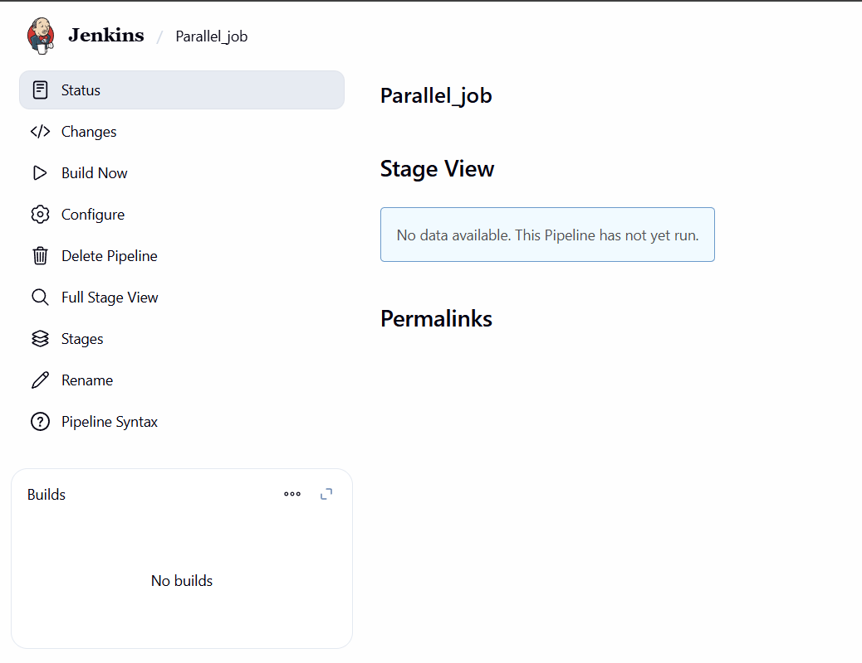
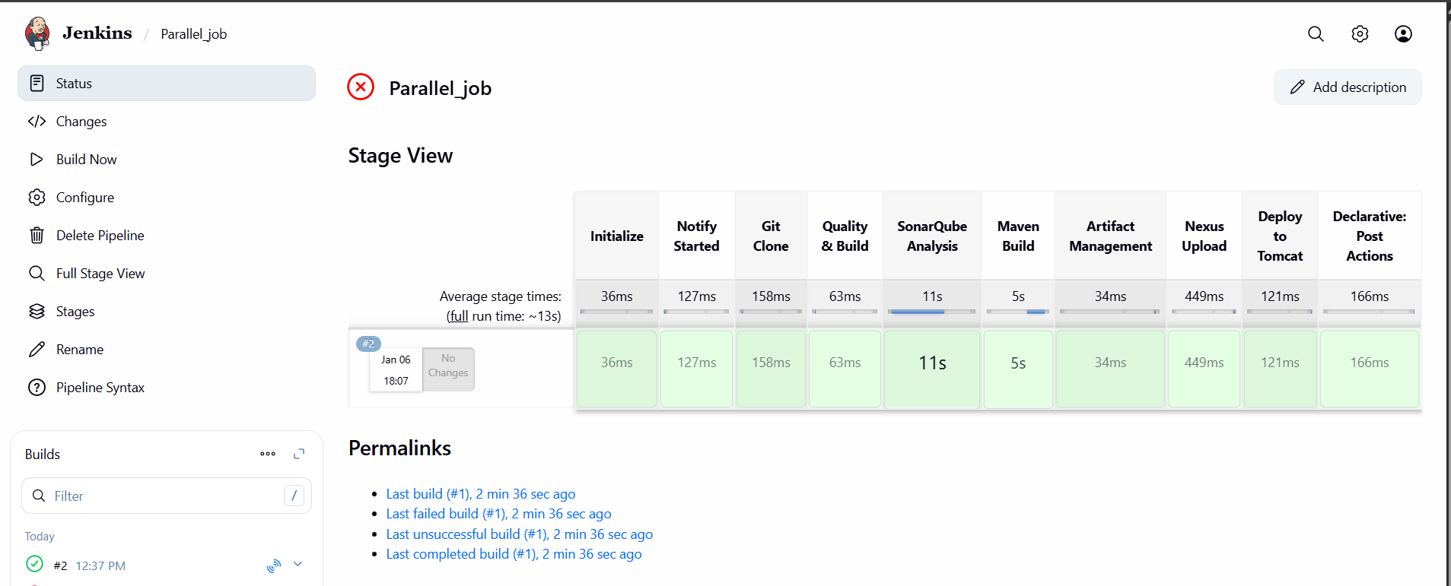
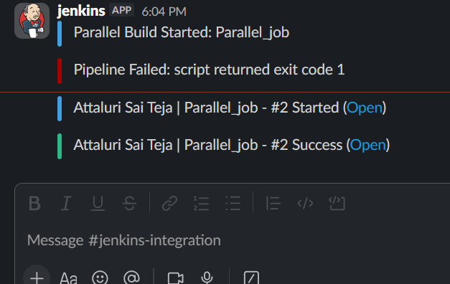
Verified all the version or snapshots in nexus repo
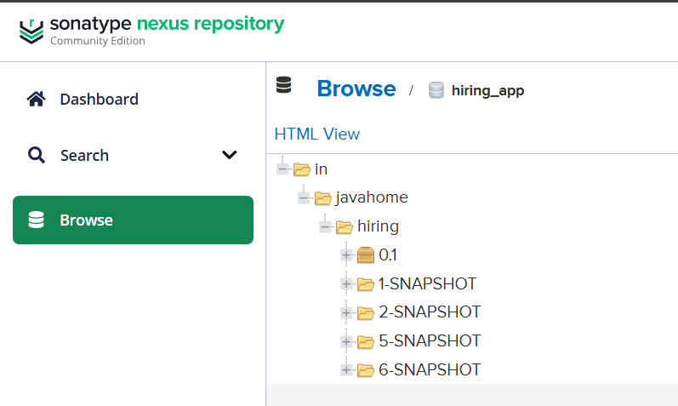

The Script I used
pipeline {
agent any
options {
timestamps()
}
environment {
MAVEN_HOME = '/opt/apache-maven-3.9.12'
PATH = "${MAVEN_HOME}/bin:${env.PATH}"

SONAR_PROJECT_KEY = 'Hiring-app'
SONAR_PROJECT_NAME = 'hiringapp'

NEXUS_URL = '54.91.134.212:8081'
NEXUS_REPOSITORY = 'hiring_app'
NEXUS_VERSION = 'nexus3'
NEXUS_PROTOCOL = 'http'

TOMCAT_URL = 'http://54.88.102.8:8080'
}
stages {
stage('Initialize') {
stages {
stage('Notify Started') {
steps {
slackSend(
color: '#439FE0',
message: "Attaluri Sai Teja | ${env.JOB_NAME} - #${env.BUILD_NUMBER} Started (<${env.BUILD_URL}|Open>)",
tokenCredentialId: 'slack_notification'
)
}
}
stage('Git Clone') {
steps {
git branch: 'main',
url: 'https://github.com/betawins/hiring-app.git'
}
}
}
}

// Parallel Execution Block
stage('Quality & Build') {
parallel {
stage('SonarQube Analysis') {
steps {
withSonarQubeEnv('sonar-server') {
sh '''
mvn org.sonarsource.scanner.maven:sonar-maven-plugin:sonar \
-Dsonar.projectKey=${SONAR_PROJECT_KEY} \
-Dsonar.projectName=${SONAR_PROJECT_NAME}
'''
}
}
}
stage('Maven Build') {
steps {
sh 'mvn clean package -DskipTests'
}
}
}
}

stage('Artifact Management') {
stages {
stage('Nexus Upload') {
steps {
script {
def WAR_FILE = sh(
script: "ls target/*.war",
returnStdout: true
).trim()

nexusArtifactUploader(
nexusVersion: NEXUS_VERSION,
protocol: NEXUS_PROTOCOL,
nexusUrl: NEXUS_URL,
repository: NEXUS_REPOSITORY,
credentialsId: 'nexus_server',
groupId: 'in.javahome',
version: "${env.BUILD_NUMBER}-SNAPSHOT",
artifacts: [[
artifactId: 'hiring',
classifier: '',
type: 'war',
file: WAR_FILE
]]
)
}
}
}
stage('Deploy to Tomcat') {
steps {
deploy adapters: [
tomcat9(
credentialsId: 'tomcat',
url: "${TOMCAT_URL}"
)
],
contextPath: 'sabear',
war: 'target/*.war'
}
}
}
}
}
post {
success {
slackSend(
color: 'good',
message: "Attaluri Sai Teja | ${env.JOB_NAME} - #${env.BUILD_NUMBER} Success (<${env.BUILD_URL}|Open>)",
tokenCredentialId: 'slack_notification'
)
}
failure {
slackSend(
color: 'danger',
message: "Attaluri Sai Teja | ${env.JOB_NAME} - #${env.BUILD_NUMBER} Failed (<${env.BUILD_URL}|Open>)",
tokenCredentialId: 'slack_notification'
)
}
}
}
Conclusion:
Parallel stage pipelines enable faster execution, better resource utilization, and are ideal for running independent tasks like tests or builds at the same time, making the CI/CD process more efficient and scalable.

